Case Study :11 — Examination Result and Grace-Mark Validation

1. Problem Statement
Develop a Python program to calculate a student's examination result and determine whether the student is eligible for grace marks based on the marks obtained.

2. Objectives
Calculate the student's examination marks and final result.
Check whether the student qualifies for grace marks.
Classify the result as Pass or Fail using conditional statements.

3. Assumptions
The maximum marks for each subject are 100.
The minimum passing mark is 40.
A maximum of 5 grace marks can be awarded per subject.
Students scoring 35–39 marks are eligible for grace marks to reach 40.
Students scoring below 35 marks are considered Fail.

4. Algorithm
- Start.
- Read the student's name and examination marks.
- Validate that marks are between 0 and 100.
- Check whether the student has scored at least 40 marks.
- If marks are between 35 and 39, award the required grace marks.
- Otherwise, classify the student as Fail.
- Display the original marks, grace marks, final marks, and result.
- Stop.

5. Flowchart

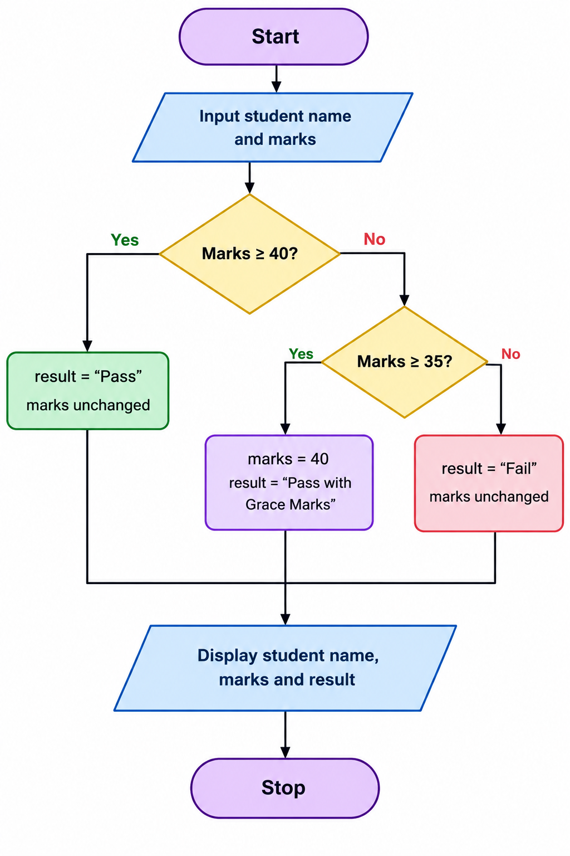

6. Pseudocode
START
INPUT name, marks

IF marks >= 40
result = "Pass"
ELSE IF marks >= 35
marks = 40
result = "Pass with Grace Marks"
ELSE
result = "Fail"
END IF

DISPLAY name, marks, result
STOP

7. Test Cases
Original marks | Grace marks | Final marks | Expected result
75 | 0 | 75 | Pass
40 | 0 | 40 | Pass
38 | 2 | 40 | Pass with Grace Marks
35 | 5 | 40 | Pass with Grace Marks
30 | 0 | 30 | Fail
105 | — | — | Invalid marks

8. Output

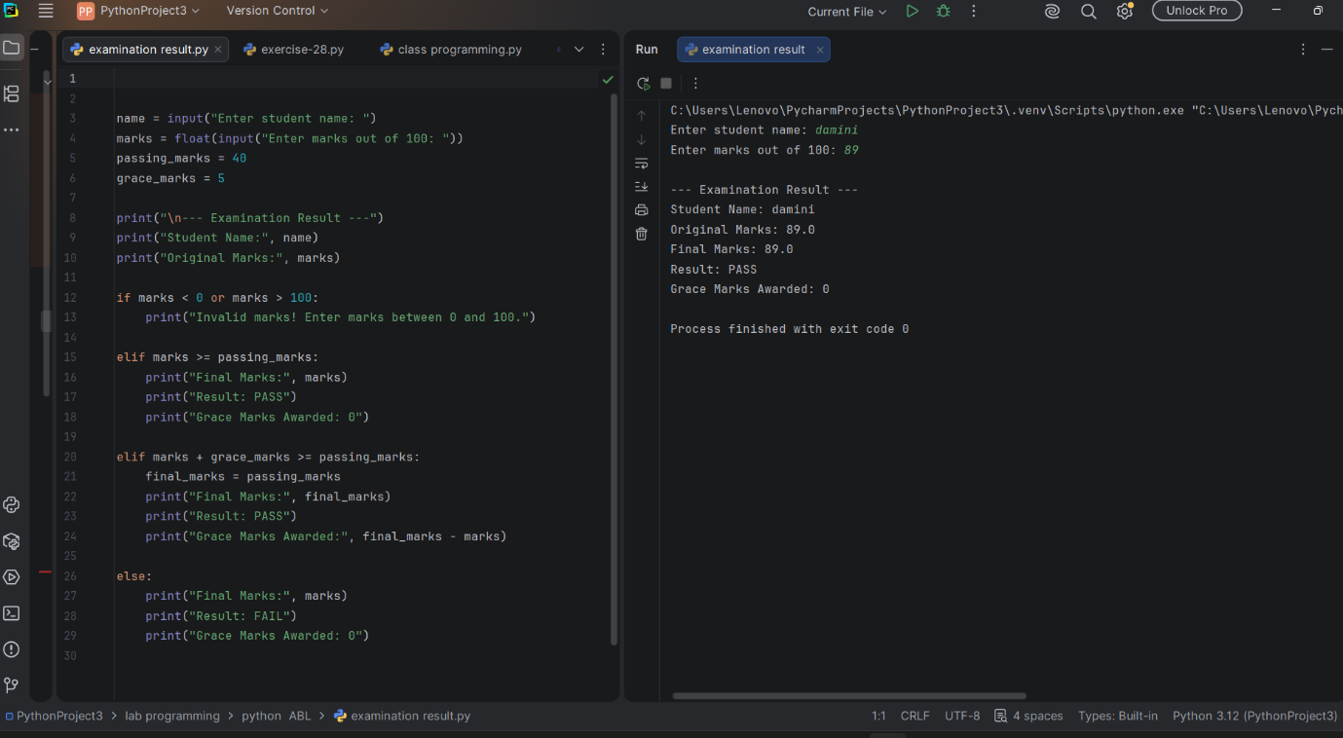

9. Conclusion
The program checks a student's examination marks, applies grace marks when the student meets the defined conditions, and displays the final result. It simplifies result validation and reduces manual calculation errors.

